Anomaly Detection

Geoffrey Chege

2022-06-10

# 1. Introduction

## Defining the question

* I am a Data analyst at Carrefour Kenya and are currently undertaking a project that will inform the marketing department on the most relevant marketing strategies that will result in the highest no. of sales (total price including tax).
* I am expected to find out if there are any anomalies in the data.

## Metric for success

* Be able to effectively detect anomalies in the products.

## Understanding the context

* Carrefour operates different store formats, as well as multiple online offerings to meet the growing needs of its diversified customer base.
* In line with the brand’s commitment to provide the widest range of quality products and value for money, Carrefour offers an unrivalled choice of more than 500,000 food and non-food products, and a locally inspired exemplary customer experience to create great moments for everyone every day.

## Recording the experimental design

* Problem Definition
* Anomaly Detection
* Provide insights based on my analysis
* Provide recommendations

## Data Relevance

* Link to the dataset: <http://bit.ly/CarreFourSalesDataset>

# 2. Loading libraries and dataset

# Load tidyverse and anomalize  
library(tidyverse)

## -- Attaching packages --------------------------------------- tidyverse 1.3.1 --

## v ggplot2 3.3.5 v purrr 0.3.4  
## v tibble 3.1.6 v dplyr 1.0.8  
## v tidyr 1.2.0 v stringr 1.4.0  
## v readr 2.1.2 v forcats 0.5.1

## -- Conflicts ------------------------------------------ tidyverse_conflicts() --  
## x dplyr::filter() masks stats::filter()  
## x dplyr::lag() masks stats::lag()

library(anomalize,warn.conflicts = FALSE)

## == Use anomalize to improve your Forecasts by 50%! =============================  
## Business Science offers a 1-hour course - Lab #18: Time Series Anomaly Detection!  
## </> Learn more at: https://university.business-science.io/p/learning-labs-pro </>

library(tibbletime)

##   
## Attaching package: 'tibbletime'

## The following object is masked from 'package:stats':  
##   
## filter

* Data:

# read data  
forecast <- read.csv("C:/Users/user/Downloads/Supermarket_Sales_Forecasting - Sales.csv")  
head(forecast)

## Date Sales  
## 1 1/5/2019 548.9715  
## 2 3/8/2019 80.2200  
## 3 3/3/2019 340.5255  
## 4 1/27/2019 489.0480  
## 5 2/8/2019 634.3785  
## 6 3/25/2019 627.6165

# 3. Anomaly Detection

## Overview

* We are to check whether there are any anomalies in the given sales dataset. The objective of this task being fraud detection.

# checking the structure of our data  
str(forecast)

## 'data.frame': 1000 obs. of 2 variables:  
## $ Date : chr "1/5/2019" "3/8/2019" "3/3/2019" "1/27/2019" ...  
## $ Sales: num 549 80.2 340.5 489 634.4 ...

# checking the shape  
dim(forecast)

## [1] 1000 2

* We have 1000 observations and 2 variables.

# converting variables to our preferred format  
forecast$Date <- as.Date(forecast$Date, "%m/%d/%Y")

str(forecast)

## 'data.frame': 1000 obs. of 2 variables:  
## $ Date : Date, format: "2019-01-05" "2019-03-08" ...  
## $ Sales: num 549 80.2 340.5 489 634.4 ...

## Visualization

# visualizing our sales  
hist(forecast$Sales,col="blue")

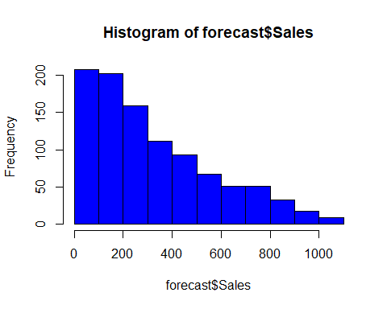

# Sales distribution over time  
library(ggplot2)  
ggplot(data = forecast, aes(x = Date, y = Sales)) +  
 geom_bar(stat = "identity", fill = "green") +  
 labs(title = "Sales distribution",  
 x = "Date", y = "Sales(ksh)")

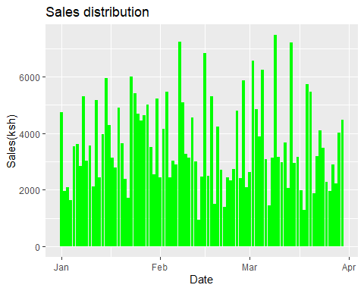

# Ordering the data by Date  
forecast = forecast %>% arrange(Date)  
head(forecast)

## Date Sales  
## 1 2019-01-01 457.443  
## 2 2019-01-01 399.756  
## 3 2019-01-01 470.673  
## 4 2019-01-01 388.290  
## 5 2019-01-01 132.762  
## 6 2019-01-01 132.027

# Since our data has many records per day,  
# We get the average per day, so that the data  
forecast = aggregate(Sales ~ Date , forecast , mean)  
head(forecast)

## Date Sales  
## 1 2019-01-01 395.4318  
## 2 2019-01-02 243.1879  
## 3 2019-01-03 259.7661  
## 4 2019-01-04 270.6148  
## 5 2019-01-05 294.7236  
## 6 2019-01-06 401.5783

# tbl_time have a time index that contains information about which column  
  
# should be used for time-based subsetting and other time-based manipulation,  
  
forecast= tbl_time(forecast, Date) # Converting data frame to a tibble time (tbl_time)  
class(forecast)

## [1] "tbl_time" "tbl_df" "tbl" "data.frame"

* I will use the following functions to detect and visualize anomalies:

forecast %>%  
 time_decompose(Sales) %>%  
 anomalize(remainder) %>%  
 time_recompose() %>%  
 plot_anomalies(time_recomposed = TRUE, ncol = 3, alpha_dots = 0.5)

## frequency = 7 days

## trend = 30 days

## Registered S3 method overwritten by 'quantmod':  
## method from  
## as.zoo.data.frame zoo

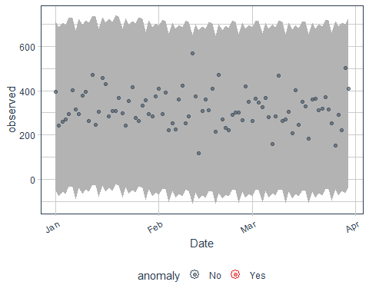

# 4. Conclusion

* There were no anomalies detected in the data.